Amazon Wireless Team

**Smart Analysis Tool (Version 1.0.0) User Guideline**

Author: YANG Tianyu (Simon)

Position: Wireless Engineering Intern

Date: 2017/10/11

Introduction

This program is to help engineer operate the date collect from factory machine and process the data by drawing statistic lines and help to generate data analysis lines which can be used in reports. Especially, it can replace the form data analysis tool, Minitab for it can deal with targeted csv file and generate the needed output.

Methodology

This tool is developed by Microsoft Visual Studio 2017, using programming language C#. It uses several class below:

using ICSharpCode.SharpZipLib.Zip;

using System;

using System.Collections.Generic;

using System.Data;

using System.Data.OleDb;

using System.Drawing;

using System.IO;

using System.Linq;

using System.Windows.Forms;

using System.Windows.Forms.DataVisualization.Charting;

including database class, compressing class, drawing class and ect.

Function

This tool’s main function is to draw data analysis line, including scatter line, normal distribution line, combined scatter line and combined normal distribution line. It can automatically import all the pass data insides and show up the total items and fail items. It can view data by dataviewer and draw graph for different test item. Moreover, it can be sorted by station and date so that users can free choose which kind of graph he or she want to print out. Also user can use search function to find the exact station or date. Last but not the least, it can save the images and also it can generate all lines and generate in a .zip file.

Procedure

Setup

Step 1:

Before you start configuring Smart Analysis Tool, please make sure that you have already uninstall old version one if you have install this program before. (You can check it in Control Panel/Programs and Features)

Step 2:

Open **SmartAnalysisTool.msi**. This program’s prerequisite is **Microsoft.NET Framework 4.6.1(x86 and x64)** or above. If your computer do not contain it, it will download prerequisites from component vendor’s web site automatically.

Step 3:

After opening SmartAnalysisTool.msi, you will see the interface as below:

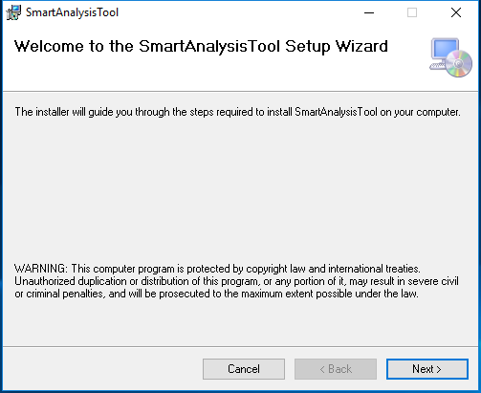

Click **Next** to continue configuration

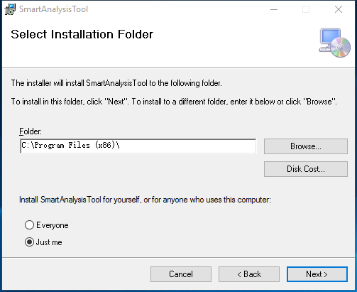

You can click **Browse…** to choose the folder you want to store the program, the default folder is C:\Program Files (x86)\. Besides, you can click **Disk Cost…** to check the remaining space for your disk, the required disk space is 2100 KB. You can select **Everyone** or **Just me** to change the authority for using this program. Click **Next** to continue configuration.

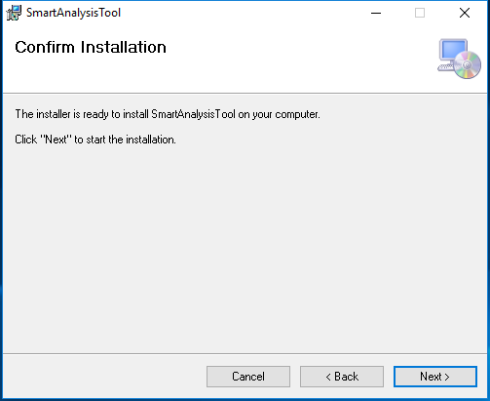

Confirm Installation and Click **Next**.

Step 4:

Successfully install the program and click **Close** to exit.

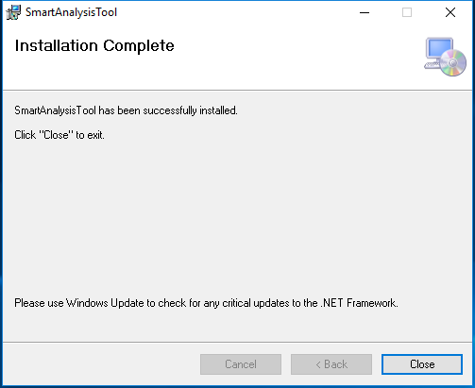

How to use the program

Step 1: start

After installing the program, you will see a shortcut file on your desktop. Double click Smart Analysis Tool to open the program.

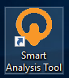

The welcome interface is shown as below:

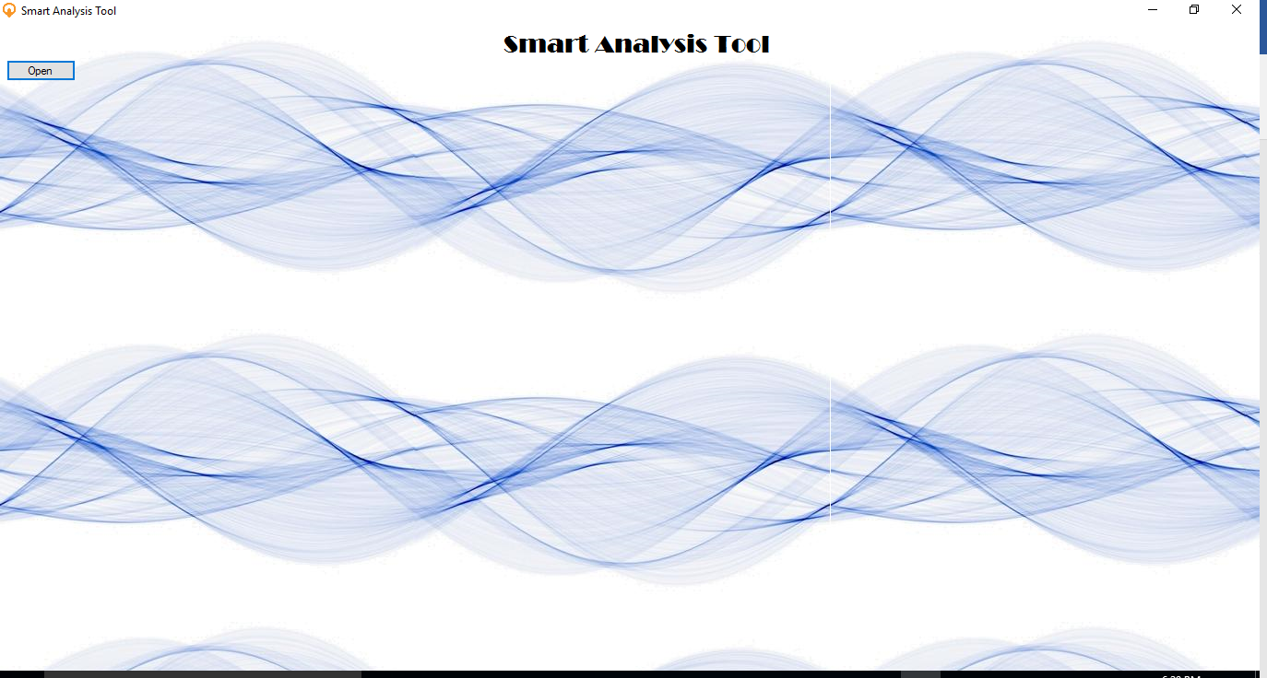

Step 2: Open a file

Click **Open** to choose the csv file you would like to open. You can multi-choose many csv files and import them into the program. Notice you can only import the standard csv file from factory, shown as below:

Notes: Before you open the file, you need to make sure that the file you would like to import is not open in your computer.

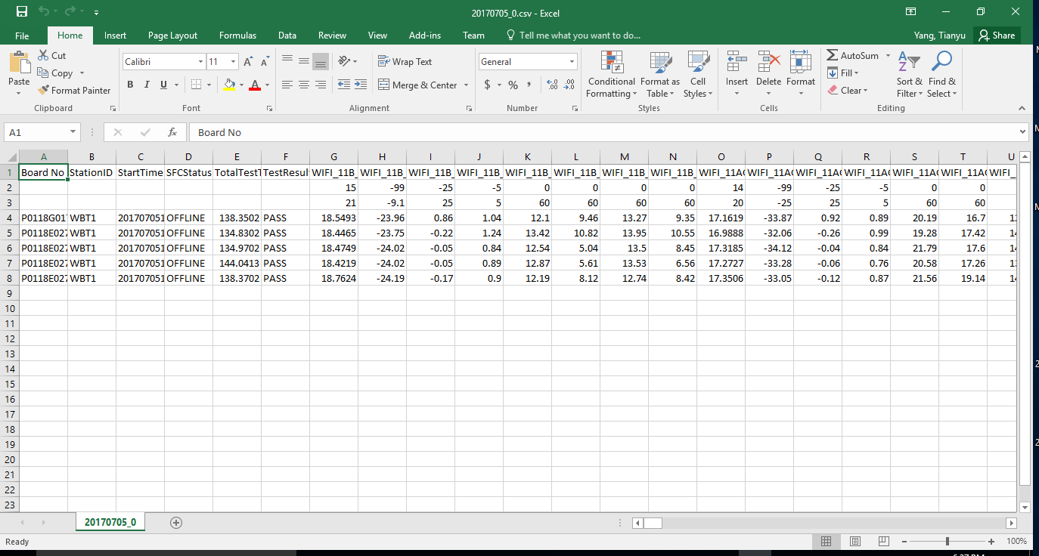

The opening interface is shown as below:

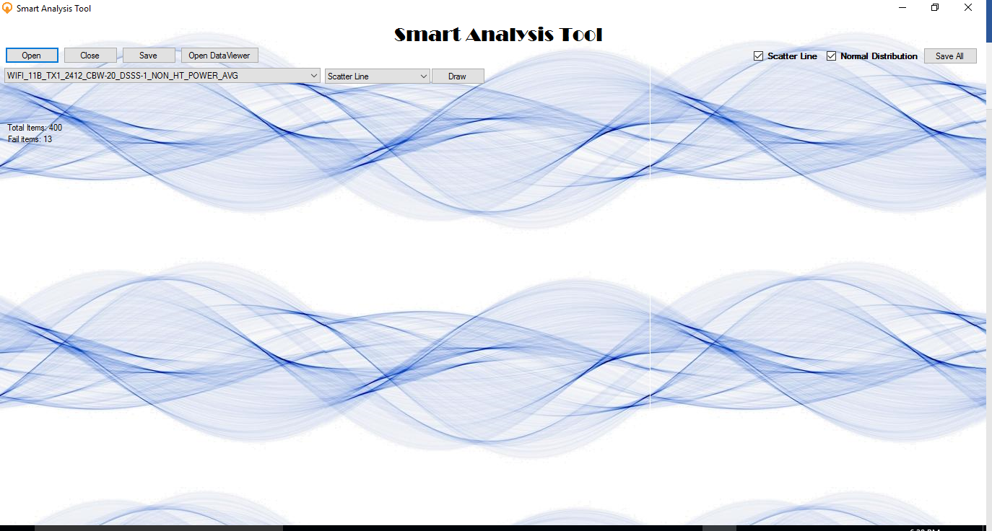

In this interface, you cannot re-click Open before you click **Close** to close the file. You can click **Save** button to save the current image. Moreover, you can click **Open DateViewer** to open Datatable for the files. After checking the data you can click Close **DateViewer** to close the Datatable.

You can select Scatter Line or Normal Distribution or both to save all required images just by clicking **Save All** button.

Next line, it shows the test items in csv file and also four kind lines you can choose to draw data analysis diagram. You can click **Draw** button to draw the graph of data.

Step 4: View and draw the graph

Function 1: View the data

Click **Open DataViewer** to check the data, which is shown as below:

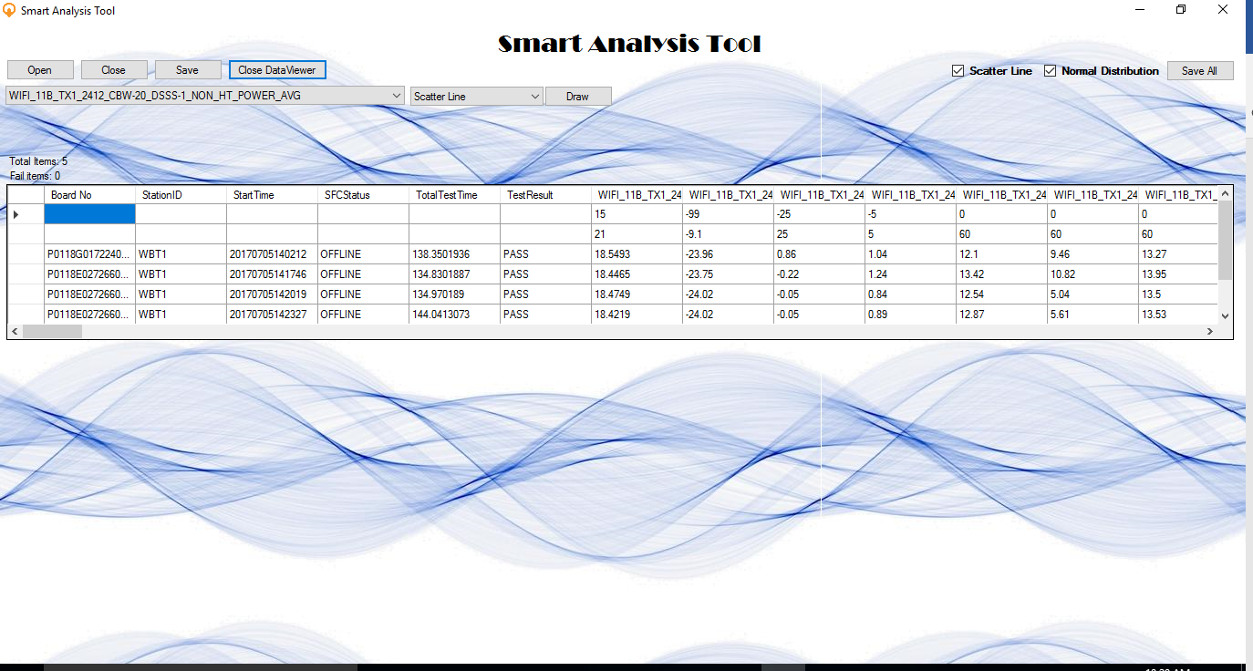

You can roll the scrolling to check the data in .csv file. This datatable is only readable so you cannot edit the data inside. Besides, you can click the column name to sort the column, shown as below:

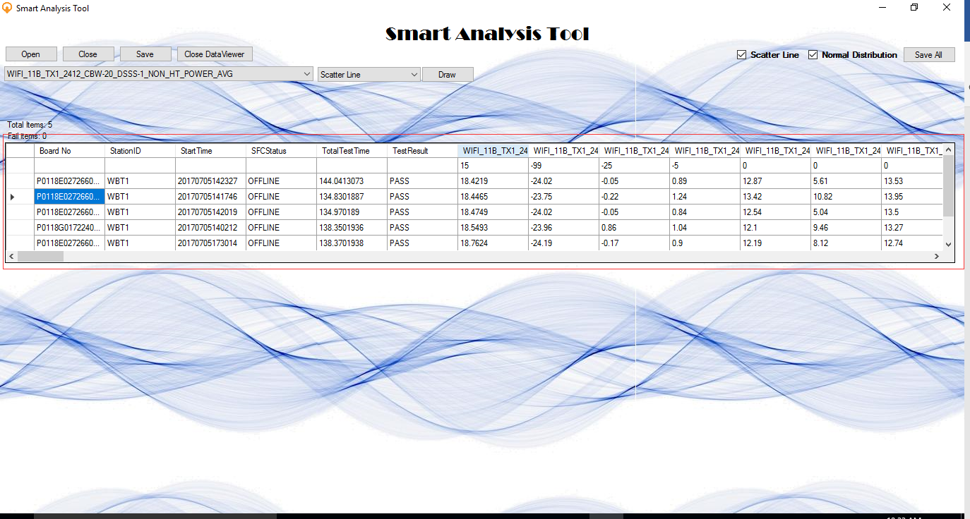

Besides, on the top of datatable, it shows the total items of data rows and fail item number in TestResult.

After viewing the data, you can click **Close DataViewer** to close the datatable.

Function 2: Draw the graph of data

This tool accepts four different kinds of lines, including Scatter Line, Normal Distribution, Combined Scatter Line and Combined Normal Distribution.

1. Scatter Line

Select Scatter Line in combo-list and Click **Draw** Button, the graph will show below:

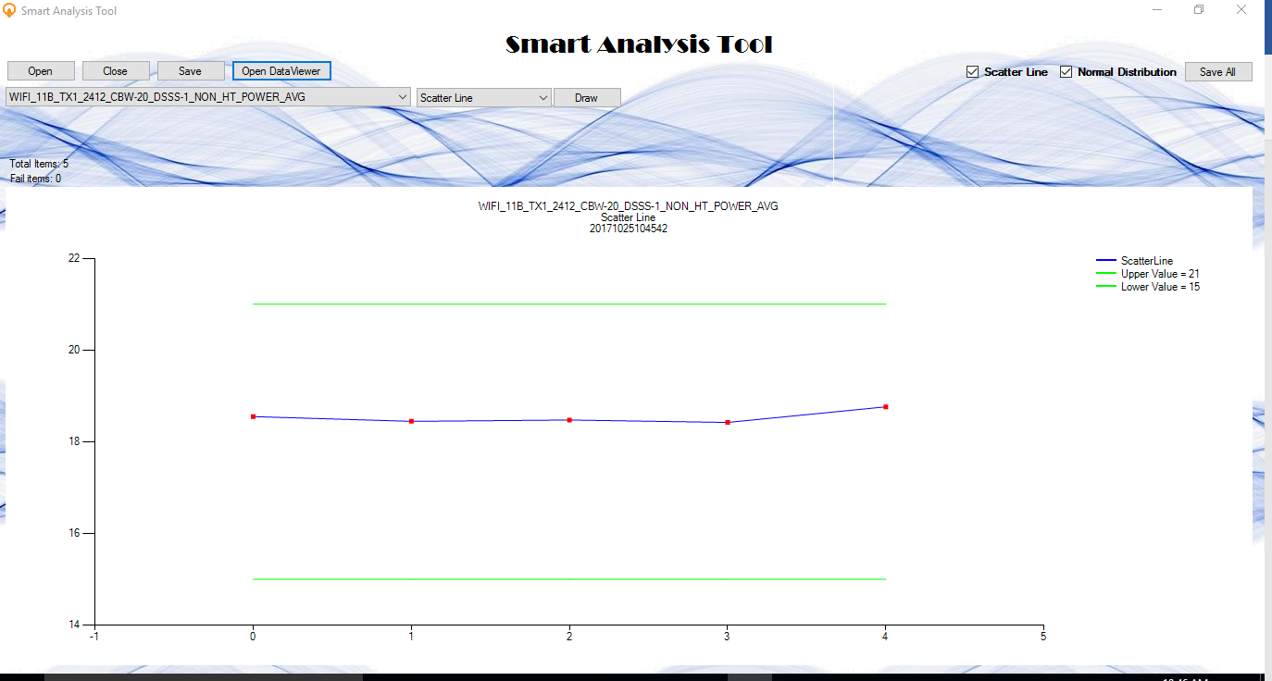

The graph shows the scatter line in selected column, the red point is the data of each row with index, the green line is the defined threshold value, and the blue line shows the trend of data. The specific value is shown in legends. Moreover, you can put your mouse on the red point to show to specific value of each point.

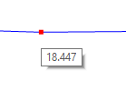

Besides, you can simply select the area of the graph to zoom in if needed, shown as below: you can click the scroll to recover the graph.

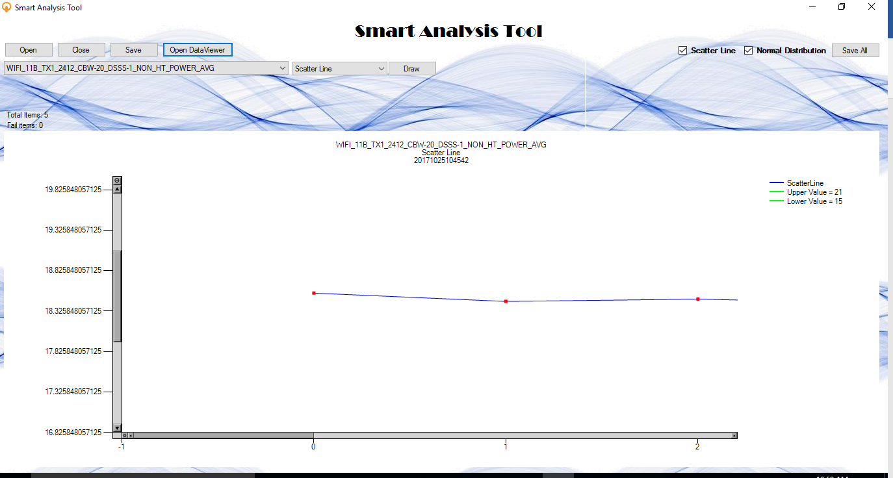

1. Normal Distribution

Select Normal Distribution in combo-list and Click **Draw** Button, the graph will show below:

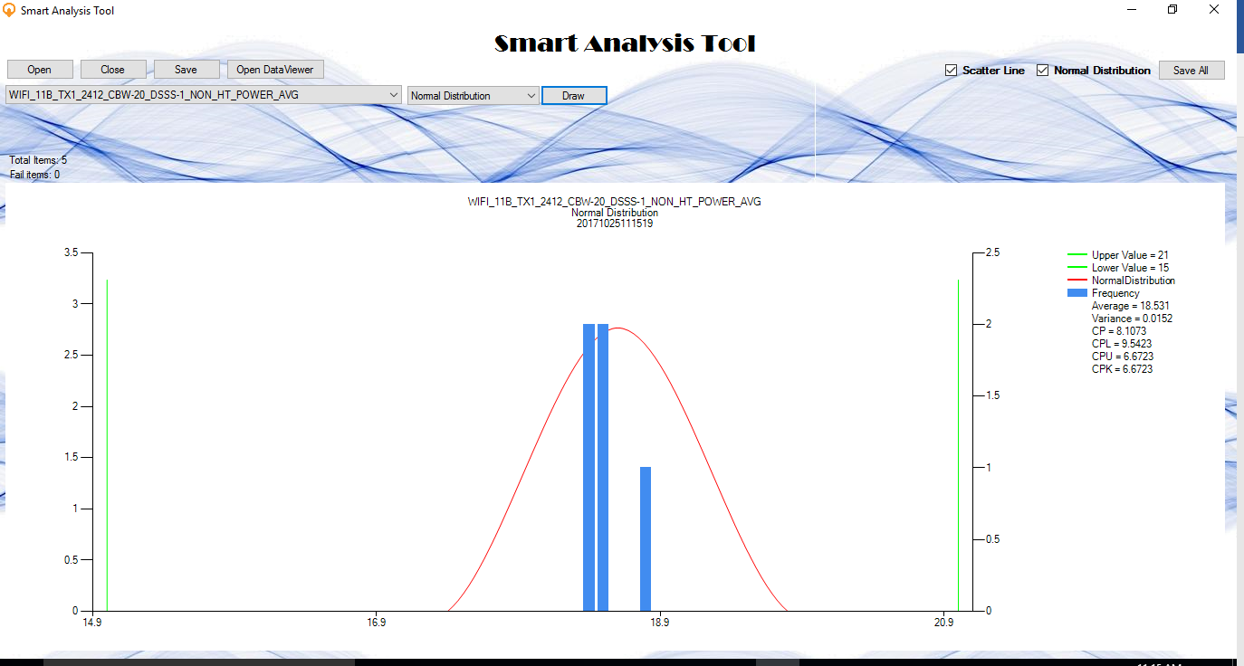

The graph shows the normal distribution line in selected column, the red line is the normal distribution line of data, the blue one is the frequency histogram of the data and the green line is the defined threshold value. The specific value is shown in legends, including average, variance, CP, CPL, CPU, CPK. Moreover, you can put your mouse on the red point to show to specific value of each column of histogram.

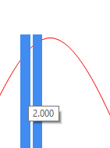

1. Combined Scatter Line

Select Combined Scatter Line in combo-list and Click **Draw** Button, the graph will show below:

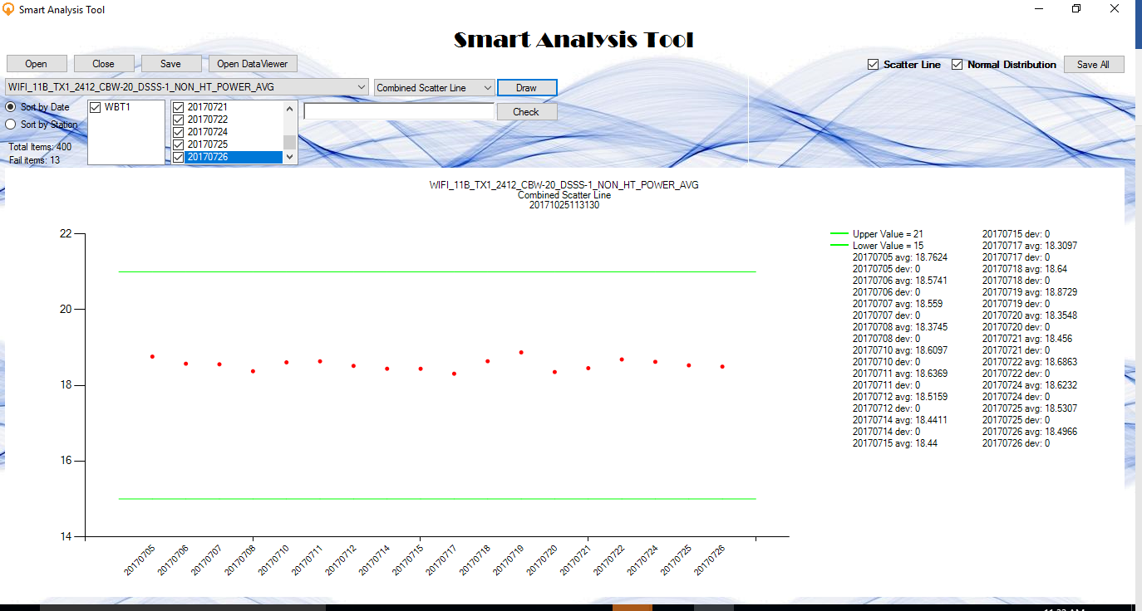

You can select Sort by Date or Sort by Station to change the type of x axis item.

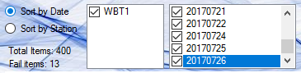

Besides, you can also select specific station or date to add or remove point in the graph. In the right side, you can also search the station or date you would like to check, you can input “WBT1” as a station or “20170707” as a date to select the combobox.

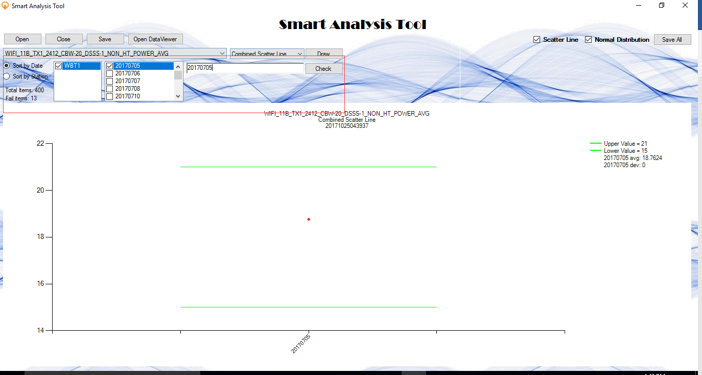

The graph shows the combined scatter line in selected rows, the red point is the data of each row with station or date, and the green line is the defined threshold value. The specific value is shown in legends, including average value and deviation value. Moreover, you can put your mouse on the red point to show to specific value of each point.

1. Combined Normal Distribution

Select Combined Normal Distribution in combo-list and Click **Draw** Button, the graph will show below:

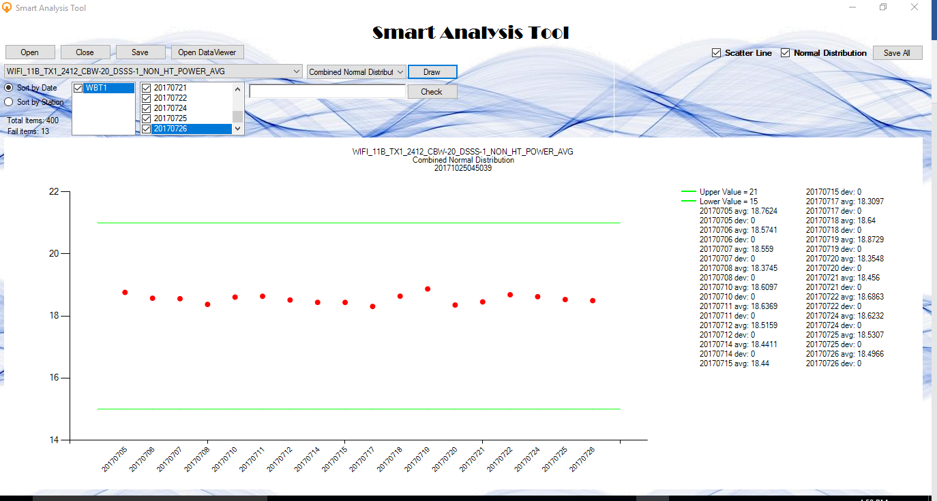

The graph shows the combined normal distribution line in selected rows, the red point is the data of each row with station or date, and the green line is the defined threshold value. The specific value is shown in legends, including average value and deviation value. Moreover, you can put your mouse on the red point to show to specific value of each point.

Step 5: Save the graphs

1. Save single graph

After you select the type of graph and display it on the screen, you can click **Save** button to save the single graph.

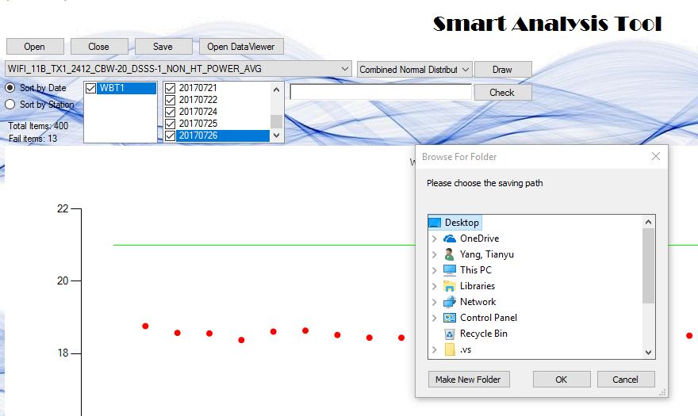

After clicking Save button, you can select the path you want to save the single graph. Moreover, you can click Make New Folder to create a folder for your graph.

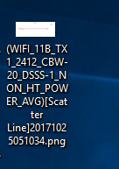

For example, this graph is saved on the desktop and the path is C:\Users\ytianyu\Desktop\ (WIFI_11B_TX1_2412_CBW-20_DSSS-1_NON_HT_POWER_AVG)[Scatter Line]20171025051034.png. The name includes the testitem, line information and creating date inside the name so that you can find or sort them easily.

1. Save multiple graphs

In the right top corner, there is **Save All** button to help save the generated graphs. The types includes Scatter Line and Normal Distribution Line.

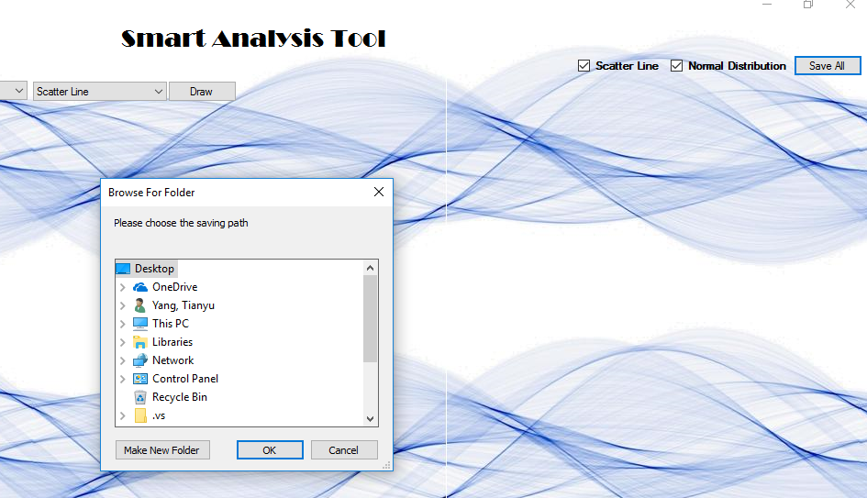

After clicking Save All button, you can select the path you want to save the multiple graphs. Moreover, you can click Make New Folder to create a folder for your graph. After selecting the saving path, all images will be compressed in a folder in your appointed path.

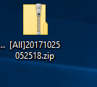

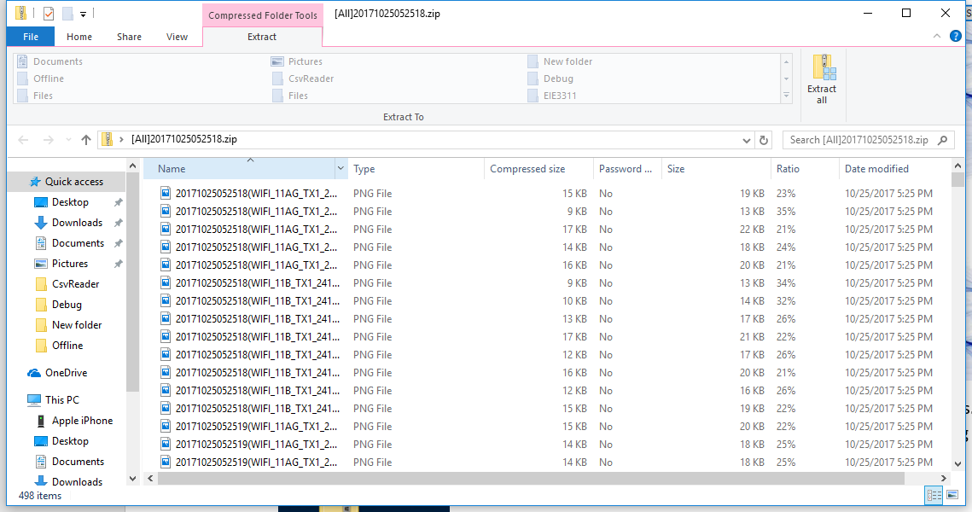

Step 6: Close the file

After processing the date and drawing the graph, you can click Close button. Notice that you must close the current file before you want to import new files.

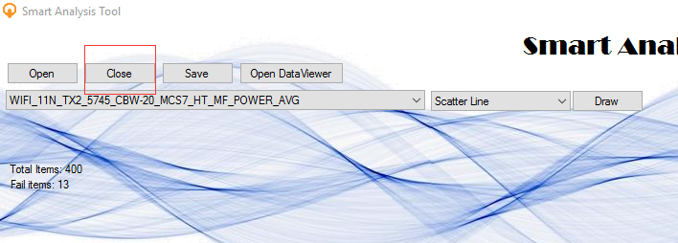

Future Development

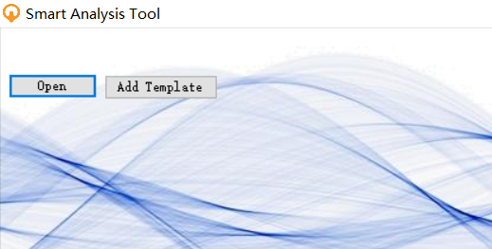

On the left top corner, you can choose “Add Template” to add the template column name for the DataTable. After selecting the file, you can see the notice shown as below:

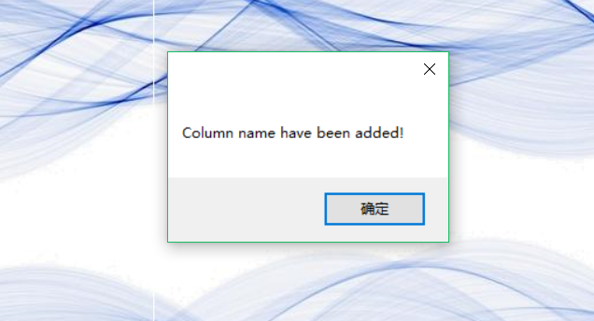

Press “Open DataViewer”, you can see the column has changed into the column name as template. If the selected csv file includes such column name, it will add in automatically, otherwise, it will remain empty.

Moreover, you can press “Save as Csv” to save such combined data into Csv file, you can choose the path and the csv will be saved in such path with the name of current timestamp.

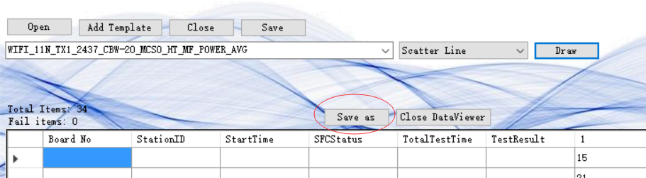

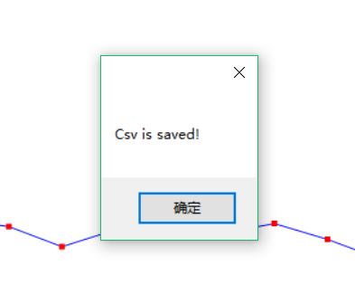

Last but not the least, you can search the column name in the column item combo box. You can just input the first several word of column and the result will be shown in list.

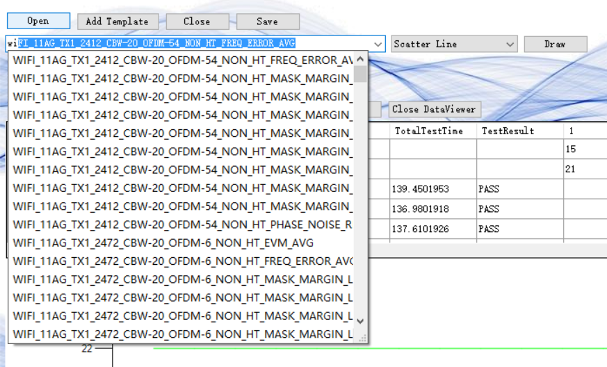

This is version 1.0.0 for Smart Analysis Tool and there are still many fields to improve. If engineer find any bugs or ideas for future development when using this program, please feel free to tell me. Your advice is my best improvement.